Appendix

Appendix A.1. Policy samples from Hangzhou and Shanghai
City | Code | Policy Title | Year | Issuing Authority
Hangzhou | P1 | Hangzhou Municipal Several Policies for Establishing a National Pilot Zone for Innovative Development of Next-Generation Artificial Intelligence | 2019 | General Office of the Hangzhou Municipal People’s Government
 | P2 | Implementation Opinions on Accelerating the Innovative Development of the Artificial Intelligence Industry | 2023 | General Office of the Hangzhou Municipal People’s Government
 | P3 | Hangzhou Action Plan for High-Quality Development of the Full Artificial Intelligence Industry Chain (2024–2026) | 2025 | Hangzhou Municipal Bureau of Economy and Information Technology (Hangzhou Municipal Bureau of Digital Economy)
 | P4 | Several Measures to Support the High-Quality Development of the Full Artificial Intelligence Industry Chain | 2024 | General Office of the Hangzhou Municipal People’s Government
 | P5 | Hangzhou 14th Five-Year Plan for the Development of the Artificial Intelligence Industry (2021–2025) | 2021 | Hangzhou Municipal Bureau of Economy  and Information Technology, Hangzhou Municipal Development and Reform Commission
Shanghai | P6 | Shanghai Implementation Opinions on Promoting the Development of  Next-Generation Artificial Intelligence | 2017 | General Office of the Shanghai Municipal  People’s Government
 | P7 | Shanghai Implementation Plan for Promoting the “AI+” Initiative to Create “Smart and Easy” Government Services | 2024 | General Office of the Shanghai Municipal  People’s Government
 | P8 | Implementation Plan on Artificial  Intelligence “Shaping Shanghai” (Mo Su Shen Cheng) | 2024 | General Office of the Shanghai Municipal  People’s Government
 | P9 | Shanghai Regulations on Promoting AI Industry Development | 2022 | 15th Shanghai Municipal People’s Congress Standing Committee
 | P10 | Shanghai Medical AI Development Work Plan (2025–2027) | 2024 | General Office of the Shanghai Municipal  People’s Government
 | P11 | Shanghai Maqiao AI Innovation Pilot Zone Construction Work Plan | 2019 | General Office of the Shanghai Municipal  People’s Government
 | P12 | Shanghai Action Plan on AI Empowering High-Quality Development of Basic Education (2024–2026) | 2024 | Shanghai Municipal Education Commission
 | P13 | Shanghai Several Measures to Promote Innovative Development of AI Large Models (2023–2025) | 2023 | Shanghai Municipal Commission of Economy and Informatization, Shanghai Municipal Development and Reform Commission, Shanghai Municipal Science and Technology Commission, Office of the Cyberspace Affairs Commission of the Shanghai Municipal Committee of the CPC, Shanghai Municipal Finance Bureau
 | P14 | Shanghai 14th Five-Year Plan for Artificial Intelligence Industry Development (2021–2025) | 2021 | Shanghai Municipal Commission of Economy and Informatization
 | P15 | Shanghai Guiding Opinions on Building the Next-Generation AI Standards System | 2021 | Shanghai Municipal Commission of Economy and Informatization, Shanghai Municipal Administration for Market  Regulation
 | P16 | Shanghai New-Generation Artificial  Intelligence Algorithm Innovation Action Plan (2021–2023) | 2021 | Shanghai Municipal Commission of Economy and Informatization, Shanghai Municipal Development and Reform  Commission, Shanghai Municipal Education Commission, Shanghai  Municipal Science and Technology Commission
 | P17 | Action Plan for Building Shanghai into an Artificial Intelligence Highland and Creating a World-Class Innovation Ecosystem (2019–2021) | 2019 | Shanghai Municipal Commission of Economy and Informatization
Table A.1. 17 AI Policies from Hangzhou and Shanghai

Appendix A.2. Keyword TF-IDF Scores
The top 100 most important keywords are identified by calculating the TF-IDF scores.
Word | TF-IDF | Word | TF-IDF | Word | TF-IDF
AI | 0.02789 | Intelligence | 0.02194 | Innovation | 0.01411
Utilization | 0.01362 | Technology | 0.01341 | Development | 0.01255
Model | 0.01107 | Domain | 0.01107 | Scenario | 0.01090
Research | 0.00933 | Priority | 0.00928 | Network | 0.00900
Chip | 0.00877 | R&D | 0.00848 | Capability | 0.00825
Algorithm | 0.00816 | Society | 0.00815 | Strategy | 0.00786
Human-Machine | 0.00757 | Nation | 0.00744 | Holism | 0.00723
Enterprise | 0.00720 | Indicator | 0.00717 | Product | 0.00678
Base | 0.00628 | Objective | 0.00626 | Security | 0.00613
Keystone | 0.00608 | Unit | 0.00600 | Situation | 0.00560
Environment | 0.00558 | Management | 0.00554 | Level | 0.00545
Information | 0.00537 | Industry | 0.00536 | Policy | 0.00511
Organization | 0.00506 | Intelligentization | 0.00483 | Support | 0.00482
Service | 0.00473 | Collaboration | 0.00472 | System | 0.00471
Mechanism | 0.00471 | Wisdom | 0.00470 | Demonstration | 0.00465
Project | 0.00458 | Talent | 0.00458 | Production | 0.00451
University | 0.00447 | Foundation | 0.00444 | Task | 0.00444
Resource | 0.00442 | Planning | 0.00438 | Integration | 0.00438
Configuration | 0.00437 | Institution | 0.00431 | Infrastructure | 0.00429
Open-Source | 0.00426 | Issue | 0.00425 | Theory | 0.00425
Methodology | 0.00424 | Direction | 0.00423 | Evaluation | 0.00418
Fundamental Theory | 0.00411 | Platform | 0.00402 | Education | 0.00402
Achievement | 0.00402 | Data | 0.00398 | Breakthrough | 0.00387
Science- and- Technology | 0.00382 | Cooperation | 0.00381 | Economy | 0.00370
Plan | 0.00369 | Standard | 0.00369 | Talent Development | 0.00365
Analysis | 0.00361 | Advantage | 0.00361 | Framework | 0.00353
Industrialization | 0.00352 | Deployment | 0.00352 | Cultivation | 0.00351
Internationality | 0.00349 | Sharing | 0.00346 | Pilot Zone | 0.00345
Cross-Media | 0.00341 | Civil-Military | 0.00340 | Sector | 0.00332
Knowledge | 0.00329 | Robot | 0.00327 | Automation | 0.00324
Collective | 0.00324 | Ecosystem | 0.00320 | Generativity | 0.00318
Orientation | 0.00316 | Decision-Making | 0.00315 | Monitoring | 0.00314
Unmanned Systems | 0.00314 | Hybridization | 0.00310 | World | 0.00308
Discipline | 0.00307
Table A.2. Top 100 Keywords Ranked by TF-IDF Scores in 103 Central-Level AI Policy Texts

Appendix A.3. Model Parameters
Parameter | Value and Description
vector_size | 150 (dimension of word vectors)
window | 5 (context window size)
min_count | 2 (minimum word frequency)
workers | 6 (number of parallel processing threads)
Table A.3. Word2Vec Model Parameter Settings

Parameter | Value and Description
n_topics | (5, 50) (parameter search space)
random_state | 42 (random seed)
init_points | 5 (number of initial random exploration points)
n_iter | 500 (number of optimization iterations)
Table A.4. Bayesian Optimization Parameters

Appendix A.4. Bertopic Model Output
Theme 1, “Artificial Intelligence Standardization and Technical Norms”, centers on establishing unified technical standards and frameworks to facilitate technology transfer and cross-sector collaboration, emphasizing achievement transformation, safety verification, and infrastructure norms. Theme 2, “Intelligent Manufacturing and System Integration”, focuses on developing new intelligent equipment and systems, particularly industrial robots with self-detection and self-calibration capabilities, as well as deep learning-based intelligent inspection and logistics systems. Theme 3, “Talent Cultivation and Artificial Intelligence Education”, revolves around reforming education models, integrating AI into curricula, establishing interdisciplinary “AI + X” training programs, and organizing competitions to build a robust talent pipeline. Theme 4, “Artificial Intelligence Governance and Risk Regulation”, underscores legal oversight, privacy and data security protection, risk assessment in ethical and employment domains, and forward-looking policies for safe and controllable development. Theme 5, “Application of Artificial Intelligence in Industry Scenarios”, highlights deep integration of AI with IoT, big data, and cloud computing in smart cities, intelligent agriculture, healthcare, finance, and precision resource management. Theme 6, “Artificial Intelligence Infrastructure and Computing Power Platforms”, concentrates on building high-speed 5G networks, AI chips, cloud platforms, and computing infrastructure. Theme 7, “International Cooperation and Global Artificial Intelligence Governance”, stresses joint international efforts in law, ethics, education, and resource sharing. Theme 8, “Fundamental Research and Theoretical Breakthroughs in Artificial Intelligence”, targets frontier basic research and paradigm-shifting computational architectures. Theme 9, “Public Participation and Popularization of Artificial Intelligence”, promotes societal engagement through exhibitions, experience centers, and public science activities. Theme 10, “Artificial Intelligence-Driven Economic and Social Transformation”, examines AI’s role in upgrading traditional industries and driving broader societal intelligent transformation. Theme 11, “Data Integration and Resource Sharing”, focuses on constructing standardized, high-quality shared data platforms and ecosystems. Finally, Theme 12, “Artificial Intelligence Innovation and Ecosystem Construction”, emphasizes establishing innovation bases and pilot zones, fostering regional cooperation, and building a collaborative government–enterprise–research ecosystem to foster multidimensional AI innovation.
Topic | Representative Content
Topic 0 | Introduce policy instruments to promote AI commercialization and safety verification; clarify infrastructure standards and operational models; formulate industry standards for cross-sector collaboration.
Topic 1 | Develop industrial robots with self-detection/correction; apply deep learning for intelligent inspection and advanced logistics equipment.
Topic 2 | Integrate AI into teaching (high-quality courses/textbooks); establish “AI + X” talent model; organize AI education activities and competitions.
Topic 3 | Establish norms for user-data protection in generative AI; strengthen risk assessment (ethics, employment); formulate forward-looking safety policies.
Topic 4 | Leverage IoT, big data, cloud computing in smart cities and ecology; promote AI in healthcare, finance, transportation; explore precision agriculture applications.
Topic 5 | Build 5G high-speed networks; develop AI chips, compilers, drivers; strengthen cloud computing and intelligent network infrastructure.
Topic 6 | Strengthen international cooperation on AI legal frameworks and rules; promote connectivity in education, research, and industry.
Topic 7 | Focus on foundational theory bottlenecks and paradigm shifts; explore hybrid augmented intelligence and new computing frameworks.
Topic 8 | Establish AI exhibition halls and experience centres; organize public science activities to increase engagement.
Topic 9 | Transform high-energy-consumption and labor-intensive industries with AI; drive industrial economy innovation and societal intelligentization.
Topic 10 | Build national big-data platforms for forestry/grasslands/ecology; promote high-quality training-data standardization and open sharing.
Topic 11 | Establish AI innovation bases and experimental platforms; promote demonstration zones and scenario-driven ecosystem collaboration.
Table A.5. Topic Identification Results

Appendix A.5. Secondary Indicator Score Criterion
Secondary Indicator | Score Criterion
X1:1 forecasting | Determine whether the policy is predictive; if it is, score = 1; if not, score = 0
X1:2 recommendation | Determine whether the policy is advisory/recommendatory; if yes, score = 1; otherwise 0
X1:3 supervision | Determine whether the policy involves oversight/monitoring; if yes, score = 1; otherwise 0
X1:4 regulation | Determine whether the policy has binding regulatory force; if yes, score = 1; otherwise 0
X1:5 guidance | Determine whether the policy provides directional guidance; if yes, score = 1; otherwise 0
X1:6 planning | Determine whether the policy is a strategic or development plan; if yes, score = 1; otherwise 0
X2:1 temporary (within the current year) | Determine whether the policy duration is within the current year; if yes, score = 1; otherwise 0
X2:2 short-term (1–3 years) | Determine whether the policy duration is 1–3 years; if yes, score = 1; otherwise 0
X2:3 medium-term (3–5 years) | Determine whether the policy duration is 3–5 years; if yes, score = 1; otherwise 0
X2:4 long-term (>5 years) | Determine whether the policy duration exceeds 5 years; if yes, score = 1; otherwise 0
X2:5 Rolling | Determine whether the policy adopts rolling or unspecified long-term implementation; if yes, score = 1; otherwise 0
X3:1 government | Determine whether government departments are explicitly targeted; if yes, score = 1; otherwise 0
X3:2 enterprise | Determine whether enterprises are explicitly targeted; if yes, score = 1; otherwise 0
X3:3 university | Determine whether universities are explicitly targeted; if yes, score = 1; otherwise 0
X3:4 research institute | Determine whether research institutes are explicitly targeted; if yes, score = 1; otherwise 0
X3:5 social organization | Determine whether social organizations are explicitly targeted; if yes, score = 1; otherwise 0
X3:6 public | Determine whether the general public is explicitly targeted; if yes, score = 1; otherwise 0
X3:7 international organization | Determine whether international organizations are explicitly targeted; if yes, score = 1; otherwise 0
X4:1 AI Standardization and Technical Norms | Determine whether the policy addresses AI standardization/technical norms; if yes, score = 1; otherwise 0
X4:2 Intelligent Manufacturing and System Integration | Determine whether the policy addresses intelligent manufacturing/system integration; if yes, score = 1; otherwise 0
X4:3 Talent Cultivation and AI Education | Determine whether the policy addresses talent cultivation/AI education; if yes, score = 1; otherwise 0
X4:4 AI Governance and Risk Regulation | Determine whether the policy addresses AI governance/risk regulation; if yes, score = 1; otherwise 0
X4:5 Application of AI in Industry Scenarios | Determine whether the policy addresses industry-specific AI applications; if yes, score = 1; otherwise 0
X4:6 AI Infrastructure and Computing Power Platforms | Determine whether the policy addresses AI infrastructure/computing power; if yes, score = 1; otherwise 0
X4:7 International Cooperation and Global AI Governance | Determine whether the policy addresses international cooperation/global governance; if yes, score = 1; otherwise 0
X4:8 Fundamental Research and Theoretical Breakthroughs in AI | Determine whether the policy addresses fundamental AI research; if yes, score = 1; otherwise 0
X4:9 Public Participation and Popularization of AI | Determine whether the policy addresses public participation/AI popularization; if yes, score = 1; otherwise 0
X4:10 AI-Driven Economic and Social Transformation | Determine whether the policy addresses AI-driven economic/social transformation; if yes, score = 1; otherwise 0
X4:11 Data Integration and Resource Sharing | Determine whether the policy addresses data integration/resource sharing; if yes, score = 1; otherwise 0
X4:12 AI Innovation and Ecosystem Construction | Determine whether the policy addresses AI innovation/ecosystem construction; if yes, score = 1; otherwise 0
X5:1 legal protection | Determine whether the policy offers legal/intellectual-property protection; if yes, score = 1; otherwise 0
X5:2 financial support | Determine whether the policy offers financial subsidies/funds; if yes, score = 1; otherwise 0
X5:3 talent incentive | Determine whether the policy offers talent attraction/subsidy measures; if yes, score = 1; otherwise 0
X5:4 resource sharing | Determine whether the policy promotes resource/data sharing mechanisms; if yes, score = 1; otherwise 0
X5:5 technical support | Determine whether the policy provides technical guidance/platforms; if yes, score = 1; otherwise 0
X5:6 tax benefits | Determine whether the policy offers tax preferences/reductions; if yes, score = 1; otherwise 0
X6:1 scientific value | Determine whether the policy reflects scientific value; if yes, score = 1; otherwise 0
X6:2 technological value | Determine whether the policy reflects technological value; if yes, score = 1; otherwise 0
X6:3 economic value | Determine whether the policy reflects economic value; if yes, score = 1; otherwise 0
X6:4 social value | Determine whether the policy reflects social value; if yes, score = 1; otherwise 0
X6:5 cultural value | Determine whether the policy reflects cultural value; if yes, score = 1; otherwise 0
X6:6 environmental value | Determine whether the policy reflects environmental value; if yes, score = 1; otherwise 0
X7:1 voluntary | Determine whether implementation is voluntary only; if yes, score = 1; otherwise 0
X7:2 mandatory | Determine whether implementation is mandatory only; if yes, score = 1; otherwise 0
X7:3 mixed | Determine whether implementation is mixed (voluntary + mandatory); if yes, score = 1; otherwise 0
X8:1 detailed content | Determine whether the policy content is specific and detailed; if yes, score = 1; otherwise 0
X8:2 scientific planning | Determine whether the policy exhibits scientific and reasonable planning; if yes, score = 1; otherwise 0
X8:3 clear objective | Determine whether the policy objectives are clear and explicit; if yes, score = 1; otherwise 0
X8:4 clear responsibility | Determine whether responsibilities of all parties are clearly assigned clearly; if yes, score = 1; otherwise 0
X8:5 stakeholder participation | Determine whether multiple stakeholders are encouraged to participate; if yes, score = 1; otherwise 0
X9:1 emergency management | Determine whether emergency management is an explicit objective; if yes, score = 1; otherwise 0
X9:2 risk prevention | Determine whether risk prevention/control is an explicit objective; if yes, score = 1; otherwise 0
X9:3 public service | Determine whether improving public service is an explicit objective; if yes, score = 1; otherwise 0
X9:4 economic development | Determine whether promoting economic development is an explicit objective; if yes, score = 1; otherwise 0
X9:5 scientific and technological innovation | Determine whether fostering S&T innovation is an explicit objective; if yes, score = 1; otherwise 0
X9:6 environmental protection | Determine whether environmental protection is an explicit objective; if yes, score = 1; otherwise 0
X9:7 national security | Determine whether safeguarding national security is an explicit objective; if yes, score = 1; otherwise 0
X9:8 resource allocation | Determine whether optimizing resource allocation is an explicit objective; if yes, score = 1; otherwise 0
X9:9 international competitiveness | Determine whether enhancing international competitiveness is an explicit objective; if yes, score = 1; otherwise 0
Table A.6. Secondary Indicator Score Criterion

Appendix A.6. Results of the Multi-Input-Output Table for Policy Samples
P | X1 |  |  |  |  |  | X2 |  |  |  |  | X3
 | X1:1 | X1:2 | X1:3 | X1:4 | X1:5 | X1:6 | X2:1 | X2:2 | X2:3 | X2:4 | X2:5 | X3:1 | X3:2 | X3:3 | X3:4
P1 | 0 | 0 | 1 | 1 | 1 | 1 | 0 | 0 | 1 | 0 | 0 | 1 | 1 | 1 | 1
P2 | 0 | 0 | 1 | 1 | 1 | 1 | 0 | 1 | 0 | 0 | 0 | 1 | 1 | 1 | 1
P3 | 1 | 0 | 1 | 1 | 1 | 1 | 0 | 1 | 0 | 0 | 0 | 1 | 1 | 1 | 1
P4 | 0 | 0 | 1 | 1 | 1 | 1 | 0 | 1 | 0 | 0 | 0 | 1 | 1 | 1 | 1
P5 | 1 | 1 | 1 | 1 | 1 | 1 | 0 | 1 | 1 | 0 | 1 | 1 | 1 | 1 | 1
P6 | 1 | 0 | 1 | 1 | 1 | 1 | 0 | 1 | 0 | 1 | 0 | 1 | 1 | 1 | 1
P7 | 0 | 0 | 1 | 1 | 1 | 1 | 0 | 1 | 0 | 0 | 0 | 1 | 1 | 0 | 0
P8 | 0 | 0 | 1 | 1 | 1 | 1 | 0 | 1 | 0 | 0 | 0 | 1 | 1 | 1 | 1
P9 | 0 | 0 | 1 | 1 | 1 | 1 | 0 | 0 | 0 | 1 | 0 | 1 | 1 | 1 | 1
P10 | 1 | 0 | 1 | 1 | 1 | 1 | 0 | 1 | 0 | 0 | 0 | 1 | 1 | 1 | 1
P11 | 1 | 0 | 1 | 0 | 1 | 1 | 0 | 1 | 1 | 1 | 0 | 1 | 1 | 1 | 1
P12 | 1 | 1 | 1 | 1 | 1 | 1 | 0 | 1 | 0 | 0 | 1 | 1 | 1 | 1 | 1
P13 | 1 | 1 | 1 | 1 | 1 | 1 | 0 | 1 | 0 | 0 | 0 | 1 | 1 | 1 | 1
P14 | 1 | 1 | 1 | 1 | 1 | 1 | 0 | 0 | 1 | 1 | 1 | 1 | 1 | 1 | 1
P15 | 0 | 1 | 1 | 1 | 1 | 1 | 0 | 1 | 0 | 1 | 1 | 1 | 1 | 1 | 1
P16 | 0 | 1 | 0 | 1 | 1 | 1 | 0 | 1 | 0 | 0 | 1 | 1 | 1 | 1 | 1
P17 | 0 | 1 | 1 | 1 | 1 | 1 | 0 | 1 | 0 | 0 | 0 | 1 | 1 | 1 | 1
P | X3 |  |  | X4
 | X3:5 | X3:6 | X3:7 | X4:1 | X4:2 | X4:3 | X4:4 | X4:5 | X4:6 | X4:7 | X4:8 | X4:9 | X4:10 | X4:11 | X4:12
P1 | 1 | 0 | 0 | 1 | 1 | 1 | 1 | 1 | 1 | 0 | 1 | 0 | 1 | 1 | 1
P2 | 1 | 0 | 0 | 1 | 1 | 1 | 1 | 1 | 1 | 0 | 1 | 0 | 1 | 1 | 1
P3 | 1 | 0 | 0 | 1 | 1 | 1 | 1 | 1 | 1 | 1 | 1 | 0 | 1 | 1 | 1
P4 | 0 | 0 | 0 | 0 | 1 | 1 | 0 | 1 | 1 | 0 | 1 | 0 | 1 | 0 | 1
P5 | 0 | 1 | 0 | 1 | 1 | 1 | 1 | 1 | 1 | 1 | 1 | 0 | 0 | 1 | 1
P6 | 0 | 0 | 0 | 1 | 1 | 1 | 1 | 1 | 1 | 1 | 1 | 0 | 1 | 1 | 1
P7 | 0 | 1 | 0 | 1 | 0 | 0 | 1 | 1 | 1 | 0 | 0 | 0 | 0 | 1 | 1
P8 | 0 | 0 | 1 | 1 | 1 | 1 | 1 | 1 | 1 | 1 | 1 | 0 | 1 | 1 | 1
P9 | 1 | 1 | 1 | 1 | 1 | 1 | 1 | 1 | 1 | 1 | 1 | 1 | 1 | 1 | 1
P10 | 0 | 0 | 0 | 1 | 0 | 1 | 1 | 1 | 1 | 0 | 1 | 0 | 0 | 1 | 1
P11 | 0 | 0 | 0 | 0 | 1 | 1 | 0 | 1 | 1 | 0 | 1 | 0 | 1 | 1 | 1
P12 | 1 | 0 | 0 | 1 | 0 | 1 | 1 | 1 | 0 | 0 | 1 | 0 | 0 | 1 | 0
P13 | 0 | 0 | 0 | 1 | 1 | 1 | 1 | 1 | 1 | 1 | 1 | 0 | 0 | 1 | 1
P14 | 1 | 0 | 1 | 1 | 1 | 1 | 1 | 1 | 1 | 1 | 1 | 0 | 1 | 1 | 1
P15 | 1 | 0 | 0 | 1 | 1 | 1 | 1 | 1 | 1 | 1 | 0 | 0 | 1 | 1 | 1
P16 | 0 | 0 | 0 | 1 | 1 | 1 | 1 | 1 | 1 | 1 | 1 | 0 | 0 | 1 | 1
P17 | 1 | 0 | 0 | 1 | 1 | 1 | 1 | 1 | 1 | 1 | 1 | 0 | 1 | 1 | 1
P | X5 |  |  |  |  |  | X6 |  |  |  |  |  | X7
 | X5:1 | X5:2 | X5:3 | X5:4 | X5:5 | X5:6 | X6:1 | X6:2 | X6:3 | X6:4 | X6:5 | X6:6 | X7:1 | X7:2 | X7:3
P1 | 1 | 1 | 1 | 1 | 1 | 0 | 1 | 1 | 1 | 1 | 0 | 0 | 1 | 1 | 1
P2 | 0 | 1 | 1 | 1 | 1 | 0 | 1 | 1 | 1 | 1 | 0 | 1 | 1 | 1 | 1
P3 | 1 | 1 | 1 | 1 | 1 | 0 | 1 | 1 | 1 | 1 | 0 | 1 | 1 | 1 | 1
P4 | 0 | 1 | 1 | 1 | 1 | 0 | 1 | 1 | 1 | 0 | 0 | 0 | 1 | 1 | 1
P5 | 1 | 1 | 1 | 1 | 1 | 1 | 1 | 1 | 1 | 1 | 0 | 1 | 1 | 0 | 1
P6 | 1 | 1 | 1 | 1 | 1 | 0 | 1 | 1 | 1 | 1 | 1 | 1 | 1 | 1 | 1
P7 | 1 | 0 | 0 | 1 | 1 | 0 | 0 | 1 | 1 | 1 | 0 | 0 | 0 | 1 | 1
P8 | 0 | 1 | 1 | 1 | 1 | 0 | 1 | 1 | 1 | 1 | 1 | 1 | 1 | 0 | 1
P9 | 1 | 1 | 1 | 1 | 1 | 1 | 1 | 1 | 1 | 1 | 0 | 1 | 1 | 1 | 1
P10 | 1 | 1 | 1 | 1 | 1 | 0 | 1 | 1 | 1 | 1 | 1 | 0 | 1 | 1 | 1
P11 | 0 | 1 | 1 | 1 | 1 | 0 | 1 | 1 | 1 | 1 | 1 | 1 | 1 | 0 | 1
P12 | 1 | 1 | 1 | 1 | 1 | 0 | 1 | 1 | 0 | 1 | 0 | 0 | 1 | 0 | 1
P13 | 1 | 1 | 1 | 1 | 1 | 0 | 1 | 1 | 1 | 1 | 0 | 0 | 1 | 1 | 1
P14 | 1 | 1 | 1 | 1 | 1 | 0 | 1 | 1 | 1 | 1 | 0 | 1 | 1 | 0 | 1
P15 | 1 | 1 | 1 | 1 | 1 | 0 | 1 | 1 | 1 | 1 | 0 | 0 | 1 | 0 | 1
P16 | 1 | 1 | 1 | 1 | 0 | 0 | 1 | 1 | 1 | 1 | 0 | 0 | 1 | 0 | 1
P17 | 1 | 1 | 1 | 1 | 1 | 1 | 1 | 1 | 1 | 1 | 0 | 0 | 1 | 0 | 1
P | X8 |  |  |  |  | X9
 | X8:1 | X8:2 | X8:3 | X8:4 | X8:5 | X9:1 | X9:2 | X9:3 | X9:4 | X9:5 | X9:6 | X9:7 | X9:8 | X9:9
P1 | 1 | 1 | 1 | 1 | 1 | 0 | 1 | 1 | 1 | 1 | 0 | 1 | 1 | 0
P2 | 1 | 1 | 1 | 1 | 1 | 1 | 1 | 1 | 1 | 1 | 1 | 1 | 1 | 0
P3 | 1 | 1 | 1 | 1 | 1 | 1 | 1 | 1 | 1 | 1 | 1 | 1 | 1 | 1
P4 | 1 | 1 | 1 | 1 | 1 | 0 | 1 | 0 | 1 | 1 | 0 | 0 | 0 | 0
P5 | 1 | 1 | 1 | 1 | 1 | 1 | 1 | 1 | 1 | 1 | 1 | 0 | 1 | 1
P6 | 1 | 1 | 1 | 1 | 1 | 1 | 1 | 1 | 1 | 1 | 1 | 1 | 1 | 1
P7 | 1 | 1 | 1 | 1 | 1 | 0 | 1 | 1 | 1 | 1 | 0 | 0 | 1 | 0
P8 | 1 | 1 | 1 | 1 | 1 | 1 | 1 | 1 | 1 | 1 | 1 | 0 | 1 | 1
P9 | 1 | 1 | 1 | 1 | 1 | 1 | 1 | 1 | 1 | 1 | 1 | 1 | 1 | 1
P10 | 1 | 1 | 1 | 1 | 1 | 1 | 1 | 1 | 1 | 1 | 0 | 0 | 1 | 0
P11 | 1 | 1 | 1 | 1 | 1 | 0 | 0 | 1 | 1 | 1 | 1 | 0 | 1 | 0
P12 | 1 | 1 | 1 | 1 | 1 | 0 | 1 | 0 | 0 | 1 | 0 | 0 | 1 | 0
P13 | 1 | 1 | 1 | 1 | 1 | 0 | 1 | 1 | 1 | 1 | 0 | 0 | 1 | 1
P14 | 1 | 1 | 1 | 1 | 1 | 0 | 1 | 1 | 1 | 1 | 1 | 0 | 1 | 1
P15 | 1 | 1 | 1 | 1 | 1 | 0 | 1 | 1 | 1 | 1 | 0 | 0 | 1 | 1
P16 | 1 | 1 | 1 | 1 | 1 | 0 | 1 | 1 | 1 | 1 | 0 | 0 | 1 | 1
P17 | 1 | 1 | 1 | 0 | 1 | 0 | 1 | 1 | 0 | 1 | 0 | 0 | 1 | 1
Table A.7. Multi-Input-Output Results of 17 Policies

Appendix A.7. Results of the Multi-Input-Output Table for Policy Samples
 | P1 | P2 | P3 | P4 | P5 | P6 | P7 | P8 | P9 | P10 | P11 | P12 | P13 | P14 | P15 | P16 | P17
X1 Policy Type | 0.67 | 0.67 | 0.83 | 0.83 | 1.00 | 0.83 | 0.67 | 0.67 | 0.67 | 0.83 | 0.83 | 1.00 | 1.00 | 1.00 | 0.83 | 0.67 | 0.83
X2 Policy Duration | 0.20 | 0.20 | 0.20 | 0.20 | 0.60 | 0.40 | 0.20 | 0.20 | 0.20 | 0.20 | 0.60 | 0.40 | 0.20 | 0.60 | 0.60 | 0.40 | 0.20
X3 Policy Target | 0.71 | 0.71 | 0.71 | 0.57 | 0.71 | 0.57 | 0.43 | 0.71 | 1.00 | 0.57 | 0.57 | 0.71 | 0.57 | 0.86 | 0.71 | 0.57 | 0.71
X4 Policy Content | 0.83 | 0.83 | 0.92 | 0.58 | 0.83 | 0.92 | 0.50 | 0.92 | 1.00 | 0.67 | 0.67 | 0.50 | 0.83 | 0.92 | 0.83 | 0.83 | 0.92
X5 Policy Incentive | 0.83 | 0.67 | 0.83 | 0.67 | 1.00 | 0.83 | 0.50 | 0.67 | 1.00 | 0.83 | 0.67 | 0.83 | 0.83 | 0.83 | 0.83 | 0.67 | 1.00
X6 Policy Function | 0.67 | 0.83 | 0.83 | 0.50 | 0.83 | 1.00 | 0.50 | 1.00 | 0.83 | 0.83 | 1.00 | 0.50 | 0.67 | 0.83 | 0.67 | 0.67 | 0.67
X7 Policy Implementation | 1.00 | 1.00 | 1.00 | 1.00 | 0.67 | 1.00 | 0.67 | 0.67 | 1.00 | 1.00 | 0.67 | 0.67 | 1.00 | 0.67 | 0.67 | 0.67 | 0.67
X8 Policy Design | 1.00 | 1.00 | 1.00 | 1.00 | 1.00 | 1.00 | 1.00 | 1.00 | 1.00 | 1.00 | 1.00 | 1.00 | 1.00 | 1.00 | 1.00 | 1.00 | 0.80
X9 Policy Objectives | 0.67 | 0.89 | 1.00 | 0.33 | 0.89 | 1.00 | 0.56 | 0.89 | 1.00 | 0.67 | 0.56 | 0.33 | 0.67 | 0.78 | 0.67 | 0.67 | 0.56
Total | 6.58 | 6.80 | 7.32 | 5.68 | 7.53 | 7.55 | 5.03 | 6.73 | 7.70 | 6.60 | 6.57 | 5.94 | 6.77 | 7.49 | 6.81 | 6.15 | 6.36
Table A.8. PMC Index Results of 17 Polocies

Appendix A.8. Average Secondary Indicator Scores of Hangzhou and Shanghai
P | X1 |  |  |  |  |  | X2 |  |  |  |  | X3
 | X1:1 | X1:2 | X1:3 | X1:4 | X1:5 | X1:6 | X2:1 | X2:2 | X2:3 | X2:4 | X2:5 | X3:1 | X3:2 | X3:3 | X3:4
Hangzhou | 0.40 | 0.20 | 1.00 | 1.00 | 1.00 | 1.00 | 0.00 | 0.80 | 0.40 | 0.00 | 0.20 | 1.00 | 1.00 | 1.00 | 1.00
Shanghai | 0.42 | 0.50 | 0.92 | 0.92 | 1.00 | 1.00 | 0.00 | 0.83 | 0.17 | 0.42 | 0.42 | 1.00 | 1.00 | 0.92 | 0.92
P | X3 |  |  | X4
 | X3:5 | X3:6 | X3:7 | X4:1 | X4:2 | X4:3 | X4:4 | X4:5 | X4:6 | X4:7 | X4:8 | X4:9 | X4:10 | X4:11 | X4:12
Hangzhou | 0.60 | 0.20 | 0.00 | 0.80 | 1.00 | 1.00 | 0.80 | 1.00 | 1.00 | 0.40 | 1.00 | 0.00 | 0.80 | 0.80 | 1.00
Shanghai | 0.42 | 0.17 | 0.25 | 0.92 | 0.75 | 0.92 | 0.92 | 1.00 | 0.92 | 0.67 | 0.83 | 0.08 | 0.50 | 1.00 | 0.92
P | X5 |  |  |  |  |  | X6 |  |  |  |  |  | X7
 | X5:1 | X5:2 | X5:3 | X5:4 | X5:5 | X5:6 | X6:1 | X6:2 | X6:3 | X6:4 | X6:5 | X6:6 | X7:1 | X7:2 | X7:3
Hangzhou | 0.60 | 1.00 | 1.00 | 1.00 | 1.00 | 0.20 | 1.00 | 1.00 | 1.00 | 0.80 | 0.00 | 0.60 | 1.00 | 0.80 | 1.00
Shanghai | 0.83 | 0.92 | 0.92 | 1.00 | 0.92 | 0.17 | 0.92 | 1.00 | 0.92 | 1.00 | 0.17 | 0.25 | 0.92 | 0.33 | 1.00
P | X8 |  |  |  |  | X9
 | X8:1 | X8:2 | X8:3 | X8:4 | X8:5 | X9:1 | X9:2 | X9:3 | X9:4 | X9:5 | X9:6 | X9:7 | X9:8 | X9:9
Hangzhou | 1.00 | 1.00 | 1.00 | 1.00 | 1.00 | 0.60 | 1.00 | 0.80 | 1.00 | 1.00 | 0.60 | 0.60 | 0.80 | 0.40
Shanghai | 1.00 | 1.00 | 1.00 | 0.92 | 1.00 | 0.33 | 0.92 | 0.92 | 0.75 | 1.00 | 0.25 | 0.08 | 1.00 | 0.75
Table A.9. Average Secondary Indicator Scores of Hangzhou and Shanghai

Appendix A.9. Statistical Validation of Inter-City Differences
These tests indicate that the small observed difference in average PMC scores (0.14 points) is not statistically meaningful and is likely attributable to sampling variation. Given the small and uneven sample sizes (n=5 and n=12), statistical power is limited, reducing the ability to detect subtle differences if they exist. These results support interpreting inter-city variations primarily through qualitative differences in individual PMC dimensions rather than overall scores.
City | N | Mean | Standard Deviation (SD) | 95% Confidence Interval
Hangzhou | 5 | 6.782 | 0.725 | [5.881, 7.683]
Shanghai | 12 | 6.642 | 0.747 | [6.167, 7.116]
Table A.10. Descriptive Statistics

Normality
City | W Statistic | p-value | Interpretation
Hangzhou | 0.942 | 0.682 | Normal (p>0.05)
Shanghai | 0.943 | 0.538 | Normal (p>0.05)
Equality of Variances
Test Statistic (F) | p-value | Interpretation
0.004 | 0.953 | Variances equal (p>0.05)
Table A.11. Assumption Checks for Parametric Testing

t-Statistic | Degrees of Freedom | p-value (two-tailed) | Conclusion
0.360 | 7.76 | 0.728 | No significant difference (p>0.05)
Table A.12. Two-Sample t-Test

U-Statistic | p-value (two-tailed) | Conclusion
33.0 | 0.799 | No significant difference (confirm t-test; p>0.05)
Table A.13. Robustness Check: Mann–Whitney U Test (Non-Parametric)

Appendix A.10. PMC-Surfaces of 17 Policies
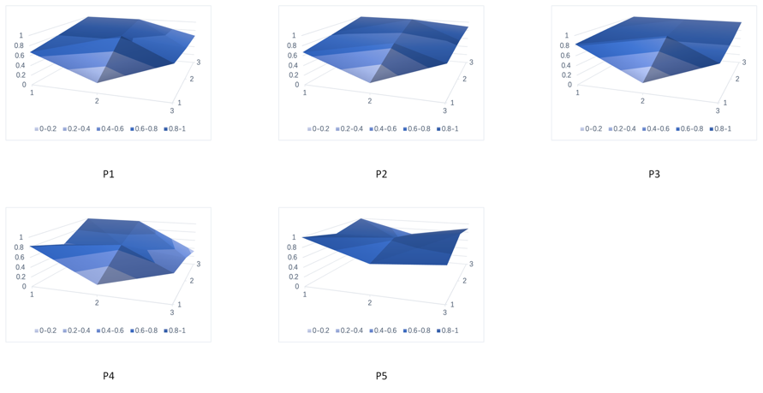
Figure A.1. PMC-surfaces of Policies from Hangzhou

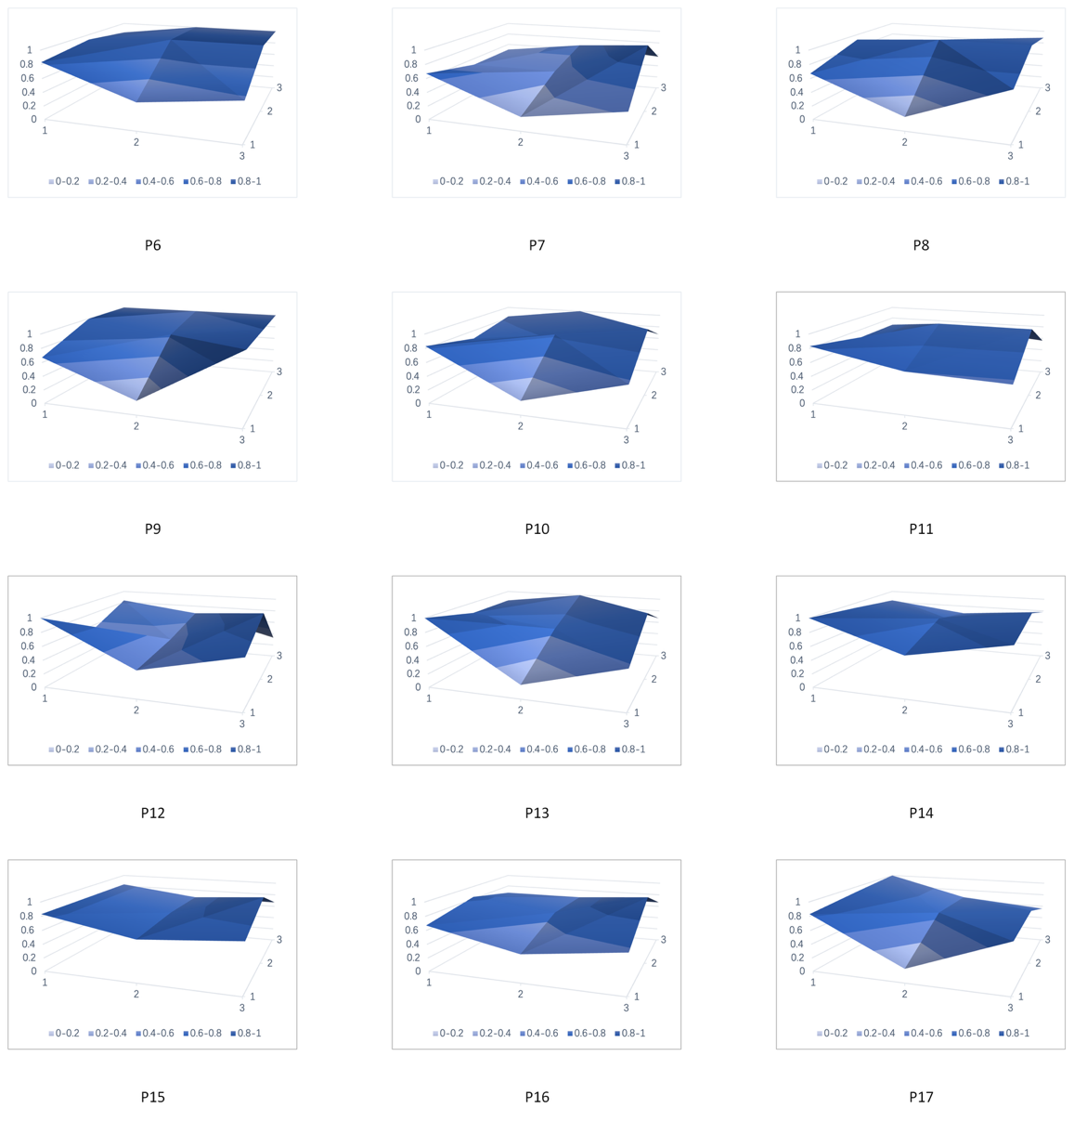
Figure A.2. PMC-surfaces of Policies from Shanghai

